**Supplementary information**

For all boxplots, dark grey lines represent the median for each group. Whiskers extend from the first (Q1) and third quartile (Q3) to the maximum value, excluding data falling outside 1.5 times the interquartile range, which are plotted as outliers. These were created using ggplot2 (Wickham, 2011).

**Table S1** – Distance transform similarity scores for five *Vespula* species commonly found in the Holarctic region.

|  |  |  |  |  |  |
| --- | --- | --- | --- | --- | --- |
|  | *germanica* | *vulgaris* | *maculifrons* | *rufa* | *pennsylvanica* |
| *germanica* | 1.000 | 0.981 | 0.979 | 0.976 | 0.975 |
| *vulgaris* | 0.981 | 1.000 | 0.989 | 0.983 | 0.987 |
| *maculifrons* | 0.979 | 0.989 | 1.000 | 0.988 | 0.982 |
| *rufa* | 0.976 | 0.983 | 0.988 | 1.000 | 0.978 |
| *pennsylvanica* | 0.975 | 0.987 | 0.982 | 0.978 | 1.000 |

**Table S2** – Details on the placement in the hoverfly phylogeny of genera not included in Katzourakis *et al.* (2001), and the arrangement of species within polytomous genera.

|  |  |  |
| --- | --- | --- |
| **Genus** | **Decision** | **Evidence for placement** |
| *Caliprobola* | Sister to *Blera*. | Rotheray and Gilbert (1999) |
| *Chrystotoxum* | Species arrangement | Masetti *et al.* (2006; Figure 2B). |
| *Claussenia* | Sister to *Cyrptopipiza.* | Newly separated genus - Vujić *et al.* (2013; Figure 3) |
| *Criorhina* | Species arrangement | Moran and Skevington (2019; Figure 27). |
| *Dasysyrphus* | Species arrangement | Figure 3; Locke and Skevington, 2013. |
| *Eriozona* | Sister of *Megasyrphus*. | Mengual *et al.* (2008) |
| *Eoseristalis* | Species arrangement | Figure 123; Morales, 2011. |
| *Eupeodes* | Species arrangement | Figure 1; Mengual *et al.,* 2018. |
| *Hammerschmidtia* | Sister of *Brachyopa*. | Rotheray and Gilbert (1999) |
| *Ischyroptera* | Sister to Portevinia and Pelecocera | Thompson (1972) |
| *Lejops* | Sister to *Eurimyia.* | Morales (2011) |
| *Mixogaster* | Sister to *Microdon*. | Reemer and Stahls (2013) |
| *Palumbia* | Sister group to *Pterallastes* next to *Milesia*. | Van Steenis and Hippa (2012) |
| *Pelecocera* | Sister to Portevina. | Vujić *et al.* (2018; Figure 2) |
| *Platycheirus* | Species arrangement | Figure 6; Young *et al.,* 2016. |
| *Platynochaetus* | Sister of *Merodon*. | Doczkal and Pape (2009) |
| *Pocota* | Basal clade of *Blera* and *Somula*. | Rotheray and Gilbert (1999) |
| *Pterallastes* | Sister of *Milesia*. | Van Steenis and Hippa (2012) |
| *Pyrophaena* | Sister of *Platycheirus*. | Young *et al.* (2016; Figure 6): currently a subgenus of *Platycheirus* but with a very different abdominal colour pattern. |
| *Rohdendorfia* | Sister of *Platycheirus*/*Melanostoma*. | Young *et al.* (2016; Figure 6): in this paper a subgenus of *Platycheirus* but usually a separate genus: it has a different abdominal colour pattern. |
| *Spazigaster* | Sister of *Platycheirus*. |
| *Sphiximorpha* | Sister of *Ceriana*. | A subgenus of *Ceriana* but separated due to differences in abdominal colour pattern. |
| *Temnostoma* | Species arrangement | Hadrava *et al.* (unpublished data) |
| *Triglyphus* | Basal genus of *Cyptopipiza* and *Claussenia hispanica*. | Vujić *et al.* (2013; Figure 3) |

**Figure S1** - An ordination plot showing model and mimic species arranged according to their distance transform dissimilarity values – species that appear closer together have (on average) higher distance transform similarity scores. Ordination calculated by Non-Metric Multidimensional Scaling, stress value 0.191. Mimic species codes are defined in the supplementary data file. Model codes: Vger = *Vespula germanica*, Vvul = *Vespula vulgaris*, Pdim = *Polistes dominula*. Images show the binarised abdominal colour patterns of selected species as used in our analysis, with the background in black and the two colour segments in white and grey. Images have been selected to cover a wide range of patterns included in the study; model species (Hymenoptera) are highlighted in red.

**Figure S2** – The three most similar (A-C) and least similar (D-F, excluding all-black species) hoverflies compared to Vespula germanica according to the distance transform analysis. A) Spilomyia interrupta (most mimetic), B) Caliprobola speciosa, C) Helophilus pendulus, D) Hadromyia grandis (least mimetic), E) Pyrophaena rosarum and F) Volucella pellucens. This result was the same in our analysis excluding species with hairy abdomens. For Vespula vulgaris, the most similar hoverflies were Spilomyia interrupta (A), Criorhina asilica and Merodon clavipes, and the least similar were Hadromyia grandis (D), Sphegina clunipes and Volucella pellucens (F). The top three mimics of Polistes dominula were Criorhina asilica, Parasyrphus vittiger and Epistrophe grossulariae, while Pyrophaena rosarum, Sphegina clunipes and Hadromyia grandis (D) were least similar.

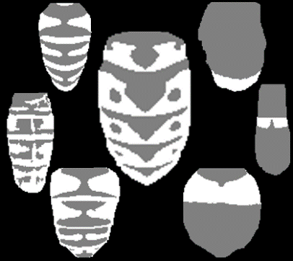

**A**

**B**

**D**

**C**

**E**

**F**

***Vespula germanica***

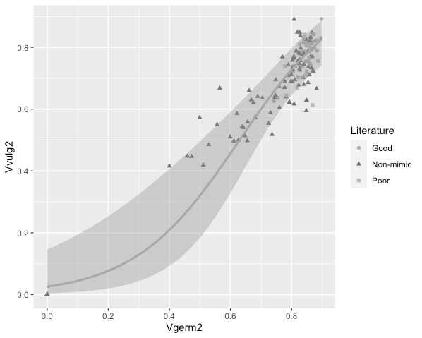

*V. vulgaris* – similarity score



**Figure S3** - The correlation between the *Vespula germanica* dataset of distance transform similarity scores for 167 hoverfly species and two additional social wasp models – *Vespula vulgaris* and *Polistes dominula*. Each graph is fit with a logistic curve.

**Figure S4 –** Frequency distribution of similarity scores describing the accuracy of social wasp mimicry in our data subset that excludes hairy species (135 species). Colour coded according to categories identified from the literature. The threshold divides possible mimics from species that have never been considered to be mimics by experts. Bin width = 0.02.

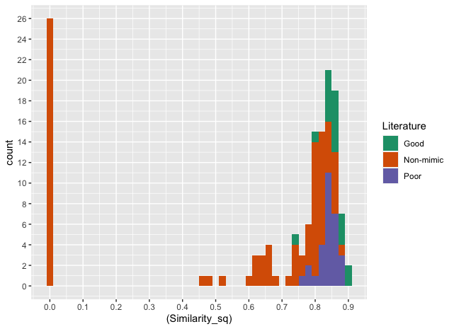

Threshold for mimicry (0.74)

Distance transform similarity score

count

Good

Non-mimic

Poor

Literature

**Figure S5 –** The distribution of similarity scores from our main dataset (Vespula germanica) for 167 hoverfly species for different categories of social wasp mimic, as reported in the literature – ‘good’ (n = 18), ‘poor’ (n = 32) and ‘non-mimics’ (n = 117). The 26 all-black species have similarity scores at zero.

**Figure S6 –** The distribution of similarity scores from our dataset excluding species with hairy abdomens (135 species) for different categories of social wasp mimic, as reported in the literature – ‘good’ (n = 18), ‘poor’ (n = 29) and ‘non-mimics’ (n = 88). The 26 all-black species have similarity scores at zero. ‘Non-mimics’ were significantly less similar to V. germanica (Kruskal-Wallis: Chi-squared = 55.29, df = 2, p < 0.001). Although the difference between ‘good’ and ‘poor’ mimics was not significant (Dunn’s test: z = 1.10, p = 0.14), note that ‘good’ mimics were marginally more similar on average.

**Figure S7** – The correlation between distance transform similarity scores for various hoverfly species from our main dataset (*Vespula germanica*), and the results of previous published evaluations of mimetic accuracy by A) pigeons trained to avoid social wasps, ranking images from worst (1) to best (10) based on peck rates (Dittrich *et al.,* 1993), and B) humans, who rated images from 1 (non-mimic) to 10 (perfect mimic; Penney *et al.,* 2012).

**Figure S8 –** The distribution of perceived similarity scores for 167 hoverfly species from a survey of human volunteers for different categories of social wasp mimicry, as reported in the literature – ‘good’ (n = 18), ‘poor’ (n = 32) and ‘non-mimics’ (n = 117).

**Figure S9** – The relationship between mean perceived similarity scores for 22 hoverfly species (given as a score out of ten, with 95% confidence intervals)from our survey of human volunteers and *f*rom a previously published survey by Penney et al. (2012). Similarity ratings were averaged across participants to give one value for similarity per species. Our survey asked 98 participants to rate species on similarity to the wasp V. germanica based on a binary image of the abdomen, whilst Penney et al. (2012) asked their 21 volunteers to rate the similarity of each hoverfly to Vespula vulgaris based on the entire body.

**Figure S10** – The relationship between mean perceived similarity scores for 167 hoverfly species from our survey of human volunteers, given as a score out of 10, and the distance transform similarity rankings, where lower numbered ranks indicate species with a closer resemblance to *V. germanica*. The line of points at rank 142 are the 26 species with entirely black abdomens.

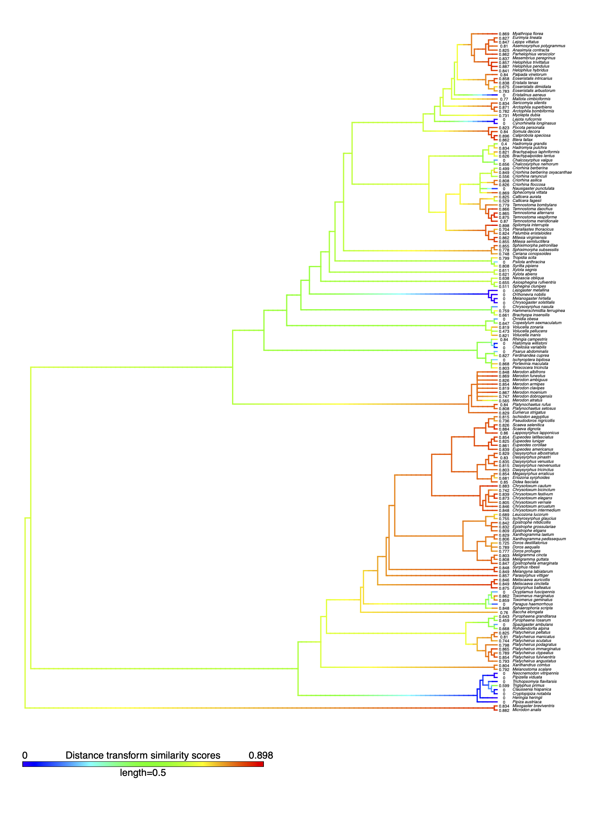

*

*

*

*

*

*

*

*

O

O

*

*

O

*

*

*

*

*

*



**Figure S11** – A literature-derived phylogeny of 167 hoverfly species. Warmer tip colours represent higher similarity to, and hence better mimicry of, the social wasp *V. germanica*. Tips are labelled with the distance transform similarity scores. Here, species were divided by the ‘majority threshold’ (0.808), the point above which the majority of species are classified as mimics in the literature.  indicates the where social mimicry has evolved at an ancestral node, and **O** shows where mimicry has been lostaccording to ‘fastAnc’ ancestral state estimates under Brownian evolution. Blank nodes before a  are non-mimetic.

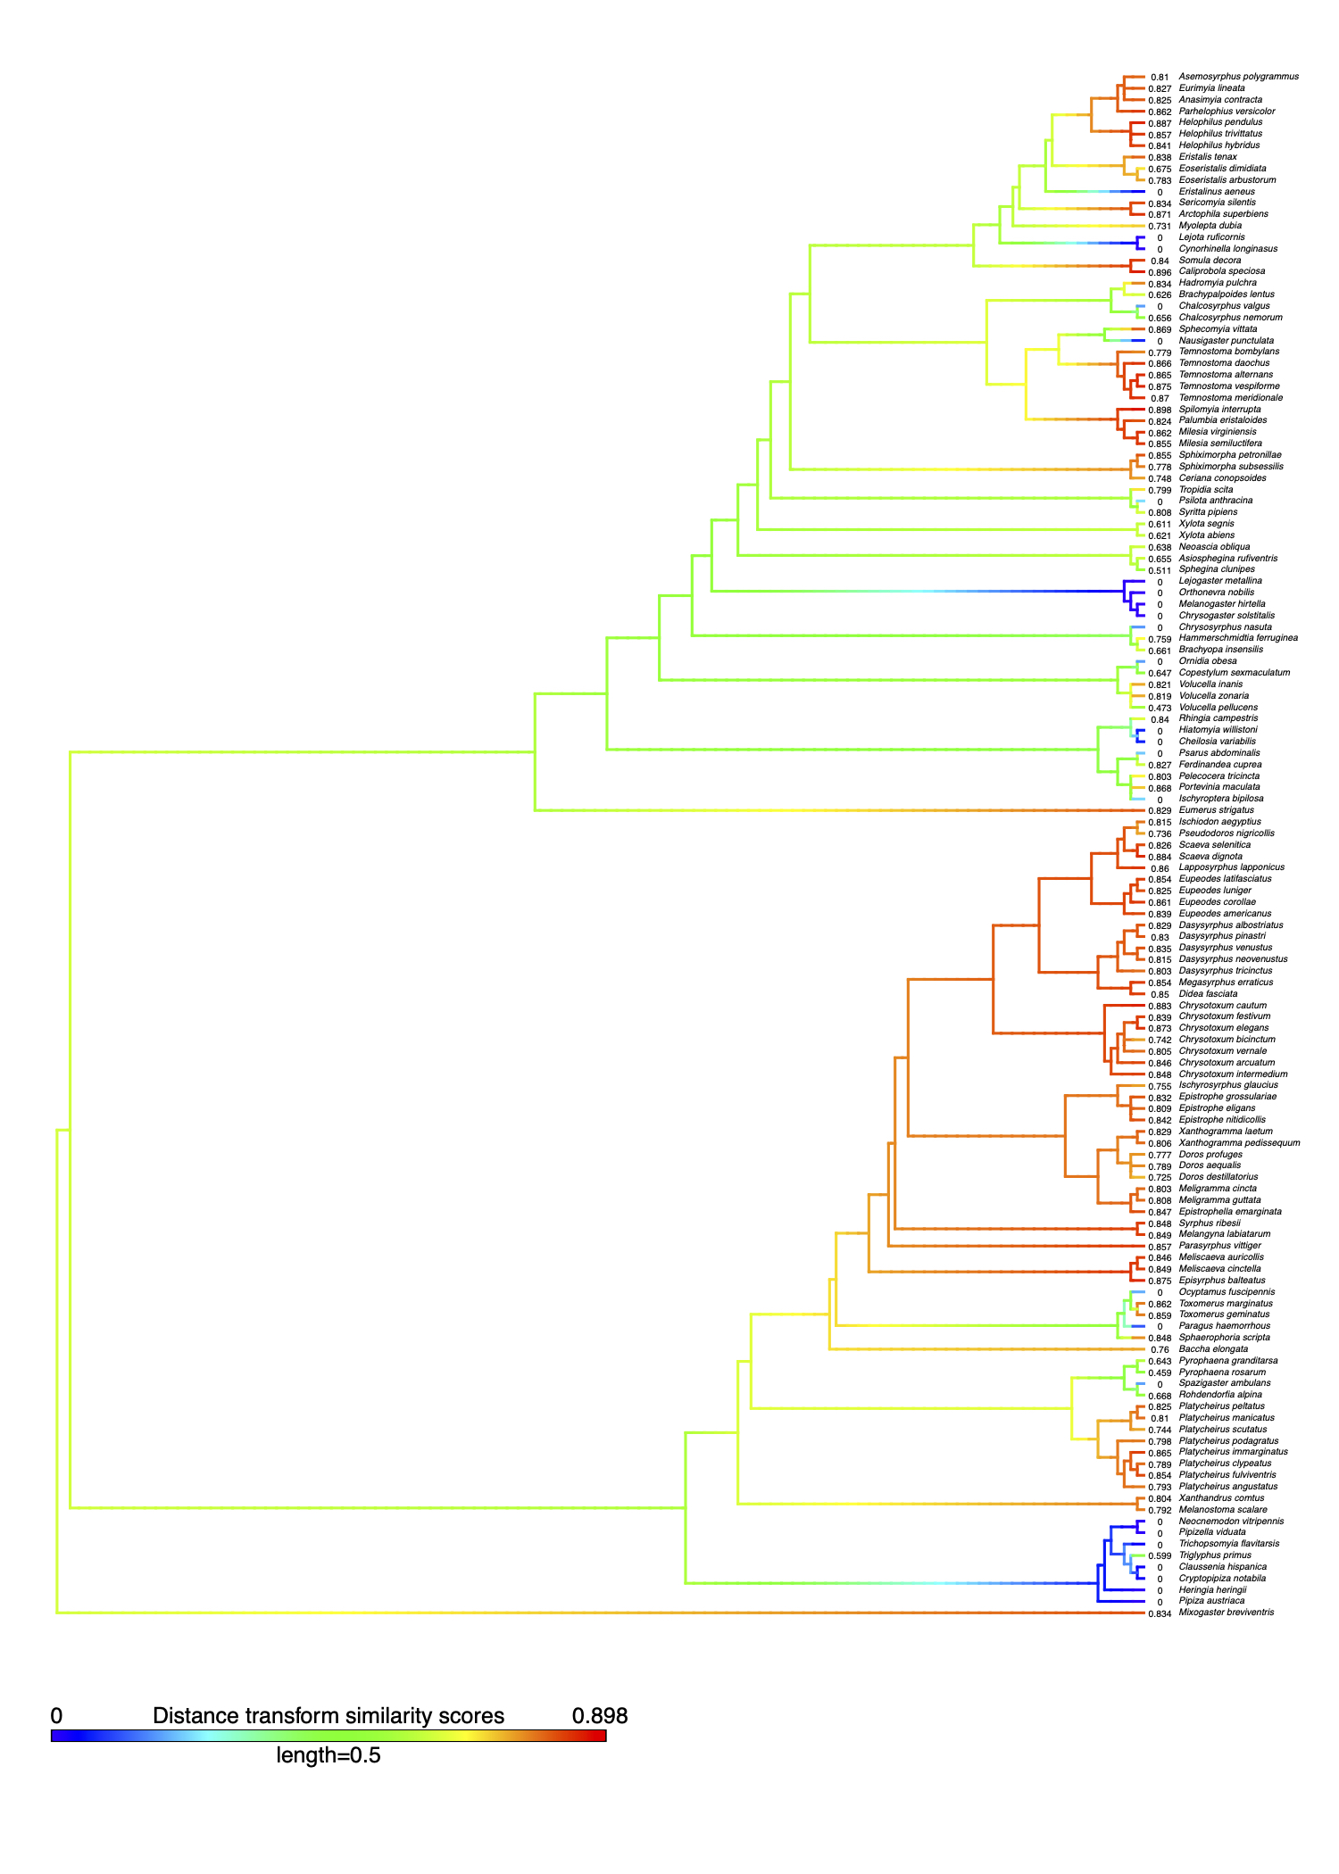

*

*

*

*

*

*

*

*

O

*

*

**Figure S12 –** A literature-derived phylogeny of 135 hoverfly species coloured according to the distance transform similarity scores for *Vespula germanica*. These species are from the data subset where hoverflies with hairy abdomens were excluded from the analysis. Warmer tip colours represent higher similarity to, and hence better mimicry of, each social wasp. Tips are labelled with the distance transform similarity scores. After similarity scores were calculated, species were divided into two categories, mimics and non-mimics, based on calibration using the literature. The threshold for mimicry was 0.74. Social wasp mimicry has evolved () 28 times (nine times at ancestral nodes) and was lost three times (once at an ancestral node (**O**))according to ‘fastAnc’ ancestral state estimates under Brownian evolution. Blank nodes before a  are non-mimetic. The phylogenetic signal was slightly weaker than when hairy species are included in the dataset(λ = 0.54, 95% CI = 0.25 – 0.77, *p* (λ = 0)< 0.001, p (λ = 1) < 0.001).



*

*

*

*

*

*

*

*

*

*

*

*

O



*Vespula vulgaris*

*fagesii*



*

*

*

*

*

*

*

*

*

*

*

*

*



*Polistes dominula*

*fagesii*

**Figure S13 –** A literature-derived phylogeny of 167 hoverfly species coloured according to the distance transform similarity scores for two wasp models, *Vespula vulargis* and *Polistes dominula*. Warmer tip colours represent higher similarity to, and hence better mimicry of, each social wasp. The threshold for mimicry was 0.64 for *Vespula vulgaris* and 0.68 for *Polistes dominula*. These thresholds and ‘fastAnc’ ancestral state estimates under Brownian evolution indicated that social wasp mimicry evolved () (*V. vulgaris*: 30 in total, 13 times at ancestral nodes; *P. dominula*: 25 in total, 13 times at ancestral nodes) and was lost (**O**) (*V. vulgaris*: 13 in total, once at an ancestral node; *P. dominula*: 12 in total) many times throughout the phylogeny. Blank nodes before a  are non-mimetic. The phylogenetic signal was significant, but not strong, for both *V. vulgaris* (λ = 0.64, 95% CI = 0.41 – 0.81, *p* (λ = 0)< 0.001, p (λ = 1) < 0.001) and *P. dominula* (λ = 0.65, 95% CI = 0.53 – 0.82, *p* (λ = 0)< 0.001, p (λ = 1) < 0.001).

**Table S3** – AIC comparison of models combining various life history traits to predict mimetic similarity scores from 167 hoverfly species using models which either did (PGLS) or did not (OLS) control for phylogenetic relatedness of species. For each model, AICs are given as a measure of model fit. For the main dataset (*V. germanica*), similarity scores were either calculated semi-objectively (“distance transform”) or from a survey of human volunteers (“survey”), for both the full dataset (n=167) and the subset where species with hairy abdomens were excluded (n=135). Models were simplified by backwards deletion of terms from a saturated model including all explanatory variables: Wing length (Wl), Larval feeding ecology (Lf), Voltinism (V) and Phenology (P). The best models are highlighted in bold.

|  |  |  |  |  |  |  |  |  |  |  |  |  |
| --- | --- | --- | --- | --- | --- | --- | --- | --- | --- | --- | --- | --- |
|  | ***Vespula germanica* (full dataset)** | | | | ***Vespula germanica* (hairless subset)** | | | | ***Vespula vulgaris*** | | ***Polistes dominula*** | |
|  | **Distance transform** | | **Survey** | | **Distance transform** | | **Survey** | | **Distance transform** | | | |
|  | **PGLS** | **OLS** | **PGLS** | **OLS** | **PGLS** | **OLS** | **PGLS** | **OLS** | **PGLS** | **OLS** | **PGLS** | **OLS** |
| Full model | 11.232 | 40.240 | 569.995 | 571.995 | 26.550 | 45.594 | 447.044 | 455.342 | -17.985 | 13.365 | -17.302 | 14.107 |
| Wl + V + P | 6.382 | **33.703** | 564.788 | 577.373 | 23.577 | 38.719 | 443.524 | 458.430 | -22.564 | **6.683** | -21.193 | **7.747** |
| **Wl +V** | **4.027** | 34.899 | **560.909** | **570.036** | **21.040** | **41.846** | **439.927** | **452.306** | **-25.215** | 8.558 | **-23.802** | 12.183 |
| Wl | 9.009 | 46.110 | 564.536 | 576.512 | 28.228 | 53.488 | 444.522 | 457.852 | -22.589 | 16.419 | -19.484 | 21.485 |
| ~1 | 20.367 | 76.271 | 566.027 | 582.99 | 41.510 | 82.865 | 452.083 | 476.286 | -11.933 | 47.788 | -9.586 | 50.832 |

**Table S4** – Coefficients from the best PGLS models describing the relationship between life history traits and mimetic similarity for our sensitivity tests on hairiness (subset of 135 species) and wasp model selection (full dataset of 167 species). Similarity scores were either calculated by pattern analysis (“distance transform”) or, for the subset excluding species with hairy abdomens only, from a survey of human volunteers (“survey”). SEM – standard error.

|  |  |  |  |  |  |  |  |
| --- | --- | --- | --- | --- | --- | --- | --- |
|  |  | | | **Coefficients** | **SEM** | **t-value** | ***p*-value** |
| **Hairless subset** | **Distance transform** | Intercept (Univoltine) | | 0.157 | 0.158 | 0.988 | 0.325 |
| Wing length | | 0.052 | 0.012 | 4.477 | **<0.001** |
| Voltinism | Bivoltine | 0.166 | 0.061 | 2.734 | **0.007** |
| Multivoltine | 0.183 | 0.077 | 2.386 | **0.018** |
| **Survey** | Intercept (Univoltine) | | 0.150 | 0.671 | 1.713 | 0.089 |
| Wing length | | 0.198 | 0.053 | 3.726 | **<0.001** |
| Voltinism | Bivoltine | -0.161 | 0.287 | -0.560 | 0.576 |
| Multivoltine | 1.004 | 0.364 | 2.757 | **0.007** |
| ***Vespula vulgaris*** | **Distance transform** | Intercept (Univoltine) | | 0.249 | 0.149 | 1.670 | 0.097 |
| Wing length | | 0.036 | 0.009 | 3.930 | **<0.001** |
| Voltinism | Bivoltine | 0.082 | 0.046 | 1.785 | 0.076 |
| Multivoltine | 0.138 | 0.066 | 2.095 | **0.038** |
| ***Polistes dominula*** | **Distance transform** | Intercept (Univoltine) | | 0.261 | 0.152 | 1.722 | 0.087 |
| Wing length | | 0.035 | 0.009 | 3.863 | **<0.001** |
| Voltinism | Bivoltine | 0.084 | 0.046 | 1.810 | 0.071 |
| Multivoltine | 0.165 | 0.066 | 2.496 | **0.014** |

**Table S5** – Average AICs (+/- SEM) for each PGLS and phyloglm model across 1000 iterations for the distance transform similarity scores, our survey data and our two different definitions of binary mimicry for 108 hoverfly species from our main dataset (*Vespula germanica*). Explanatory variables: Wing length (Wl), Larval feeding ecology (Lf), Voltinism (V) and Phenology (P).

|  |  |  |  |  |  |
| --- | --- | --- | --- | --- | --- |
|  | **PGLS** | | **phyloglm** | | |
|  | **Distance transform** | **Survey** | **Mimicry threshold** | **Majority threshold** | **Literature categories** |
| Full model | 48.130 (0.082) | 375.54 (0.191) | 150.63 (0.402) | 135.85 (0.233) | 135.02 (0.231) |
| Wl + V + P | 43.002 (0.076) | 370.984 (0.166) | 145.87 (0.301) | 131.66 (0.209) | 128.21 (0.212) |
| **Wl +V** | **39.461 (0.077)** | **369.168 (0.165)** | **144.09 (0.297)** | 129.14 (0.240) | 123.56 (0.257) |
| Wl | 43.840 (0.068) | 369.493 (0.167) | 146.28 (0.319) | **127.61 (0.181)** | **114.53 (0.214)** |
| ~1 | 53.852 (0.100) | 373.888 (0.187) | 144.57 (0.086) | 143.31 (0.089) | 125.54 (0.064) |

**Figure S14 –** The relationship between wing length and A) distance transform similarity scores, fit with a logistic curve, and B) similarity scores from a survey of human volunteers, fitted with a line to represent the best model, which included wing length and voltinism as explanatory variables. Both are for 167 hoverfly species from our main dataset (*Vespula germanica*).

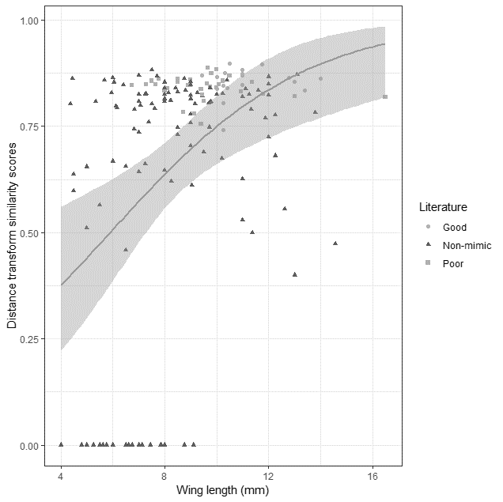

Wing length (mm)

Distance transform similarity scores

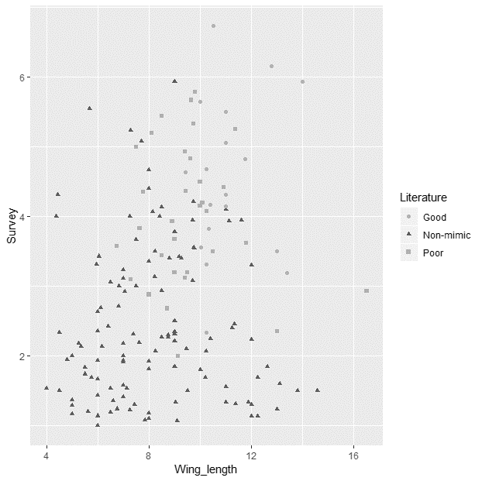

Wing length (mm)

Average similarity from survey

Literature

Good

Non-mimic

Poor



**A**

**B**

**

**B**

**A**

**Figure S15 –** The relationships between voltinism and A) distance transform similarity scores and B) similarity scores from a survey of human volunteers for 167 hoverfly species. See Table S8 for statistics.

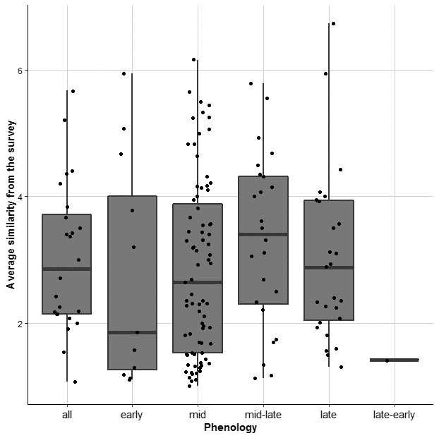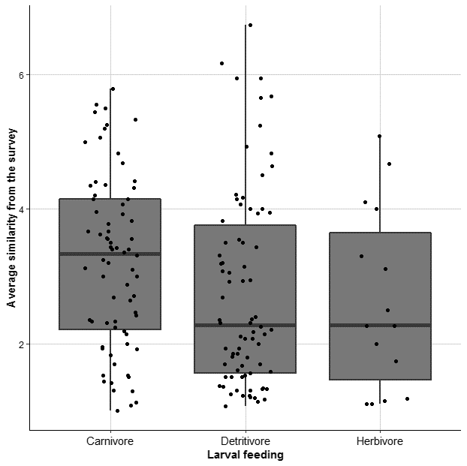

**B**

**A**

**Figure S16** - The relationships between larval feeding ecology and phenology and A) the distance transform scores from our main dataset (*Vespula germanica*) and B) similarity scores from our survey of human volunteers for 167 hoverfly species. See Table S8 for statistics.

**Table S6** – HPD (Higher Posterior Density) confidence intervals (95%) for the best models for the PGLS analyses of the *Vespula germanica* distance transform similarity scores and our survey, as well as the phyloglmanalysis for each definition of binary mimicry, across 1000 possible resolved phylogenies for our reduced dataset of 108 species.

|  |  |  |  |  |  |  |  |  |
| --- | --- | --- | --- | --- | --- | --- | --- | --- |
|  | | | | | | **Coefficients** | **t/z-value** | ***p*-value** |
| **PGLS** | **Distance transform** | Intercept | | | | 0.067 to 0.239 | 0.407 to 1.323 | 0.162 to 0.651 |
| Wing length | | | | 0.040 to 0.062 | 2.844 to 4.480 | **7.4x10-6 to 3.5x10-3** |
| Voltinism | Bivoltine | | | 0.161 to 0.213 | 2.012 to 2.809 | **0.006 to 0.046** |
| Multivoltine | | | 0.170 to 0.208 | 1.726 to 2.190 | 0.031 to 0.087 |
| λ = 0.447 to 0.579 | | | | | | |
| **Survey** | Intercept | | | | 0.819 to 1.566 | 1.778 to 2.982 | 0.002 to 0.065 |
| Wing length | | | | 0.126 to 0.231 | 2.138 to 4.139 | **1.7x10-5 to 2.6x10-2** |
| Voltinism | | Bivoltine | | -0.293 to 0.218 | -0.781 to 0.592 | 0.469 to 0.998 |
| Multivoltine | | 0.602 to 1.157 | 1.240 to 2.648 | 0.004 to 0.185 |
| λ = 1x10-6 to 0.179 | | | | | | |
| **phyloglm** | **Mimicry threshold** | Intercept | | | | -5.509 to -2.774 | -4.625 to –2.632 | **2.7x10-6 to 8.1x10-3** |
| Wing length | | | | 0.332 to 0.742 | 2.895 to 4.858 | **1.0x10-6 to 3.7x10-3** |
| Voltinism | | | Bivoltine | 0.390 to 1.520 | -0.545 to 2.038 | 0.009 to 0.888 |
| Multivoltine | 0.940 to 2.427 | 1.232 to 2.369 | 0.011 to 0.202 |
| Alpha = 1.920 to 54.598 | | | | | | |
| **Majority threshold** | Intercept | | | | -5.076 to -2.491 | -4.477 to -2.902 | **3.3x10-6 to 3.5x10-3** |
| Wing length | | | | 0.352 to 0.695 | 3.293 to 4.784 | **8.8x10-7 to 8.9x10-4** |
| Alpha = 16.272 to 54.598 | | | | | | |
| **Literature categories** | Intercept | | | | -5.981 to -4.144 | -4.710 to –3.931 | **1.8x10-6 to 7.7x10-5** |
| Wing length | | | | 0.368 to 0.557 | 3.244 to 4.188 | **4.6x10-6 to 1.0x10-3** |
| Alpha = 7.144 to 54.598 | | | | | | |

**Table S7** – The percentage of each predictor in the best models of the distance transform binary data for *V. germanica* across 1000 iterations, based on different thresholds for mimicry.

|  |  |  |  |  |
| --- | --- | --- | --- | --- |
| **Threshold** | **Percentage of best models (%)** | | | |
|  | Wing length | Voltinism | Larval feeding ecology | Phenology |
| Mimicry threshold | 70.0 | 52.4 | 41.6 | 39.3 |
| Majority threshold | 98.5 | 39.9 | 4.5 | 2.5 |
| Literature categories | 89.6 | 18.1 | 21.6 | 8.7 |

**Table S8** – Descriptive statistics for distance transform similarity scores and our survey data in relation to ecological variables.

|  |  |  |  |  |  |  |
| --- | --- | --- | --- | --- | --- | --- |
|  | | | **Distance transform** | | **Survey data** | |
|  | Groups | Sample size | Median | Range | Median | Range |
| **Voltinism** | Univoltine | 125 | 0.808 | 0.400 to 0.898 | 2.46 | 1 to 6.74 |
| Bivoltine | 13 | 0.819 | 0.675 to 0.884 | 3 | 1.13 to 4.5 |
| Multivoltine | 29 | 0.848 | 0.808 to 0.887 | 4.35 | 1.07 to 5.79 |
| **Larval feeding ecology** | Carnivore | 74 | 0.815 | 0.599 to 0.884 | 3.335 | 1 to 5.79 |
| Detritivore | 78 | 0.808 | 0.400 to 0.898 | 2.275 | 1.07 to 6.74 |
| Herbivore | 15 | 0.819 | 0.565 to 0.869 | 2.27 | 1.1 to 5.08 |
| **Phenology** | All | 26 | 0.809 | 0.744 to 0.887 | 2.855 | 1.07 to 5.67 |
| Early | 13 | 0.812 | 0.556 to 0.868 | 1.85 | 1.01 to 5.94 |
| Mid | 77 | 0.808 | 0.000 to 0.896 | 2.64 | 1 to 6.16 |
| Mid-late | 24 | 0.839 | 0.511 to 0.884 | 3.405 | 1.13 to 5.79 |
| Late | 29 | 0.819 | 0.621 to 0.898 | 2.88 | 1.3 to 6.74 |
| Late-early | 1 | 0.736 | 0.736 to 0.736 | 1.41 | 1.41 to 1.41 |

**References**

Doczkal, D. and Pape, T., 2009. *Lyneborgimyia magnifica* gen. et sp. n.(Diptera: Syrphidae) from Tanzania, with a phylogenetic analysis of the Eumerini using new morphological characters. *Systematic Entomology*, *34*(3), pp.559-573.

Locke, M.M. and Skevington, J.H., 2013. Revision of Nearctic *Dasysyrphus* Enderlein (Diptera: Syrphidae). *Zootaxa*, *3660*(1), pp.1-80.

Masetti, A., Luchetti, A., Sommaggio, D., Burgio, G. and Mantovani, B., 2006. Phylogeny of *Chrysotoxum* species (Diptera: Syrphidae) inferred from morphological and molecular characters. *European Journal of Entomology*, *103*(2), pp.459-467.

Mengual, X., Ståhls, G. and Rojo, S., 2008. First phylogeny of predatory flower flies (Diptera, Syrphidae, Syrphinae) using mitochondrial COI and nuclear 28S rRNA genes: conflict and congruence with the current tribal classification. *Cladistics*, *24*(4), pp.543-562.

Mengual, X., Ståhls, G., Láska, P., Mazánek, L. and Rojo, S., 2018. Molecular phylogenetics of the predatory lineage of flower flies *Eupeodes‐Scaeva* (Diptera: Syrphidae), with the description of the Neotropical genus *Austroscaeva* gen. nov. *Journal of Zoological Systematics and Evolutionary Research*, *56*(2), pp.148-169.

Morales, M.N., 2011. Phylogeny of the tribe Eristalini (Diptera, Syrphidae, Eristalinae) inferred from morphological characters. PhD Thesis, Federal University of Paraná.

Thompson, F.C., 1972. A contribution to a generic revision of the Neotropical Milesinae (Diptera: Syrphidae). *Arquivos de Zoologia (São Paulo)*, *23*(2), pp.73-215.

van Steenis, J. and Hippa, H., 2012. Revision and phylogeny of the Oriental hoverfly genus *Korinchia* Edwards (Diptera: Syrphidae). *Tijdschrift voor Entomologie*, *155*(2-3), pp.209-268.

Vujić, A., Ståhls, G., Ačanski, J., Bartsch, H., Bygebjerg, R. and Stefanović, A., 2013. Systematics of Pipizini and taxonomy of European Pipiza Fallén: molecular and morphological evidence (Diptera, Syrphidae). *Zoologica Scripta*, *42*(3), pp.288-305.

Vujić, A., Ståhls, G. and Radenković, S., 2018. Hidden European diversity: a new monotypic hoverfly genus (Diptera: Syrphidae: Eristalinae: Rhingiini). *Zoological Journal of the Linnean Society*, pp.1-24.

Wickham, H., 2011. ggplot2. *Wiley Interdisciplinary Reviews: Computational Statistics*, *3*(2), pp.180-185.